

kb ENGINEERING Coatings SDN BHD

COMPANY PROFILE



KB ENGINEERING COATINGS SDN. BHD(Co. No: 831283D)

No. 22, Jalan TS 6/9, Taman Industri Subang, 47510 Subang Jaya, Selangor Darul Ehsan

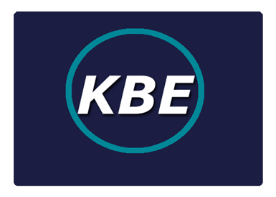

**Content**

1. Company Details 2-3
2. Vision & Mission Statement 4
3. Core Values 5
4. Service & Capabilities 6
5. Thermal Spray Machinery 7-8
6. Sample Jobs 9-15

1. Company Documents 15-20
2. Thank you in appreciation

Company Details

KB ENGINEERING COATINGS SDN. BHD(Co. No: 831283D)

No. 22, Jalan TS 6/9, Taman Industri Subang, 47510 Subang Jaya, Selangor Darul Ehsan

Address: No.22, Jalan TS 6/9, Taman Industri Subang,

47510 Subang Jaya, Selangor Darul Ehsan

Telephone: 03-56212388

Fax: 03-56215266

Directors:

1. DATO’ DR. IR. MOHD ABDUL KARIM BIN ABDULLAH
2. JERRY BIN HJ SIRAT

Year of Incorporation: 29th August 2008

Company Secretary: Koo Associates

No.43, Jalan SS15/2A

47500 Subang Jaya

Selangor Darul Ehsan

Tel: 03-56214778

KB ENGINEERING COATINGS SDN. BHD(Co. No: 831283D)

No. 22, Jalan TS 6/9, Taman Industri Subang, 47510 Subang Jaya, Selangor Darul Ehsan

**VISION**

To constantly provide the best services, coatings and weld repair solutions for our valued clients with “Total Customer Satisfaction”

**MISSION STATEMENT**

Our clients and partners will receive “ Total Customer Satisfaction” through the following activities :

* Excellent response time.
* Meeting job delivery schedule is our priority.
* High quality products recommended and used.
* Highest possible skill level and professionalism applied.
* Constantly apply cost saving methods.

KB ENGINEERING COATINGS SDN. BHD(Co. No: 831283D)

No. 22, Jalan TS 6/9, Taman Industri Subang, 47510 Subang Jaya, Selangor Darul Ehsan

***Core Values***

***Pursuit of Excellence***

*We strive for the highest professional standards in our work and aim to be the best in everything we do*

***Safety***

*We regard safety as an essential part of all our operations. We maintain and adopt practices that promote the safety of our customers and staff*

***Integrity***

*We conduct ourselves professionally at all times and in all circumstances.*

***Costumer-Centric***

*Our Costumer are our number one priority. Everything begins and ends with our costumer.*

**Services and Capabilities**

KB ENGINEERING COATINGS SDN. BHD(Co. No: 831283D)

No. 22, Jalan TS 6/9, Taman Industri Subang, 47510 Subang Jaya, Selangor Darul Ehsan

Thermal Spray Services

1. JP 5000 HVOF (High Velocity Oxy Fuel)
2. Flame Spray
3. Rokide Ceramic
4. Arc Spray

Coatings

* Tungsten Carbide, Chrome Carbide, Ceramics-Aluminum Oxide, Chrome Oxide, Zirconium Oxide, Nickel Alloys, stainless steel, food grade alloy, Babbitt, aluminum, copper and it’s alloys and others

Special Repair and Joining Welding.

*Cast Iron, Steel Castings, Low & High alloyed steel, aluminum, copper and its alloys and others.

Other Services

1. Laser Welding and Engraving
2. Special Component /Parts Fabrication C/W Thermal Spray Coatings
3. Drilling
4. Milling
5. Turning
6. Grinding
7. Finishing

*Thermal Spray Processes*

KB ENGINEERING COATINGS SDN. BHD(Co. No: 831283D)

No. 22, Jalan TS 6/9, Taman Industri Subang, 47510 Subang Jaya, Selangor Darul Ehsan

*HVOF (TAFA JP 5000)*

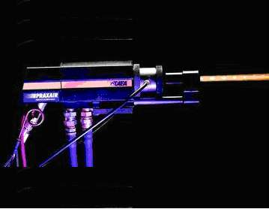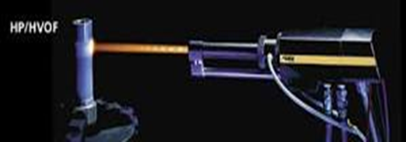

KB ENGINEERING COATINGS SDN. BHD(Co. No: 831283D)

No. 22, Jalan TS 6/9, Taman Industri Subang, 47510 Subang Jaya, Selangor Darul Ehsan

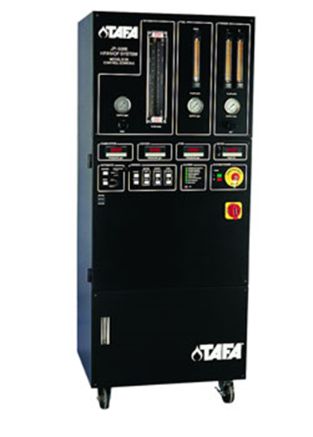

*Twin Arc Spray*

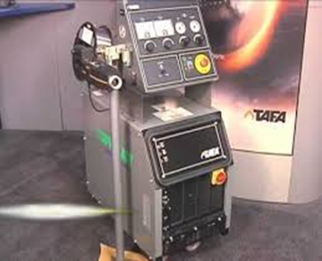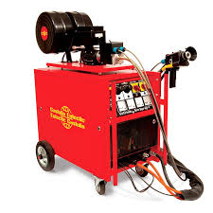

*Saint Gobain Rokide (Flame Spray)*

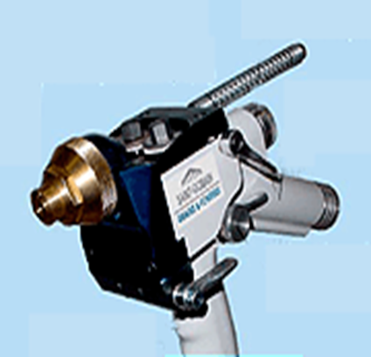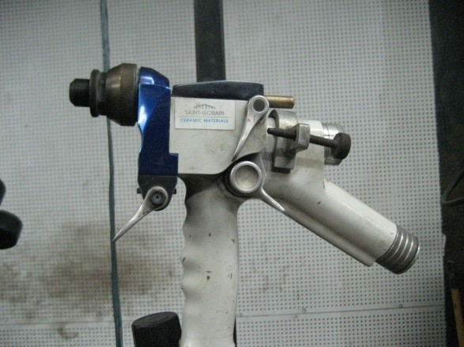

Superjet Eutalloy Torch Flame Spray Process (Hot)

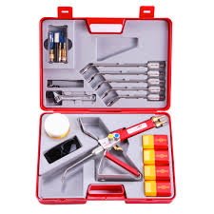

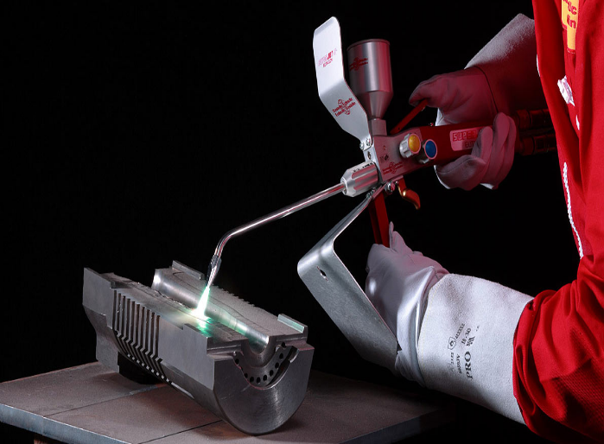

KB ENGINEERING COATINGS SDN. BHD(Co. No: 831283D)

No. 22, Jalan TS 6/9, Taman Industri Subang, 47510 Subang Jaya, Selangor Darul Ehsan

*Sample Jobs*

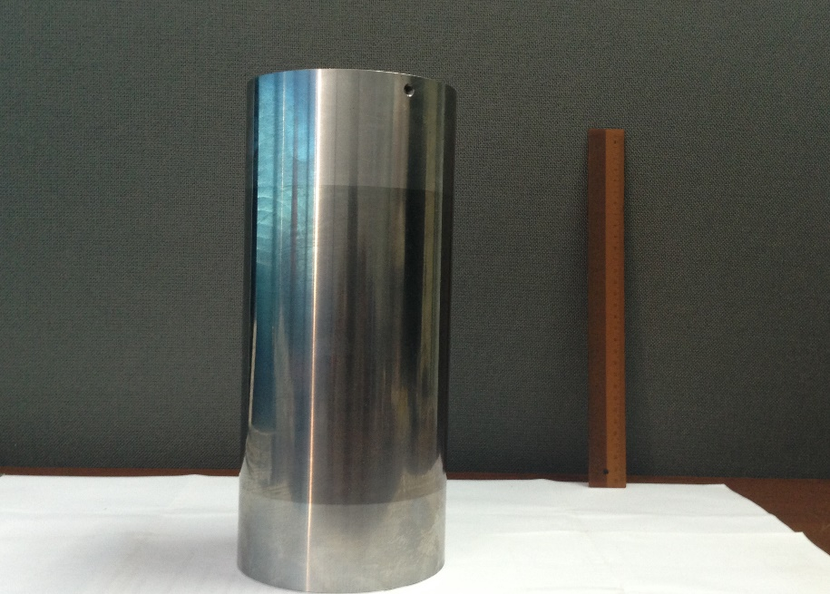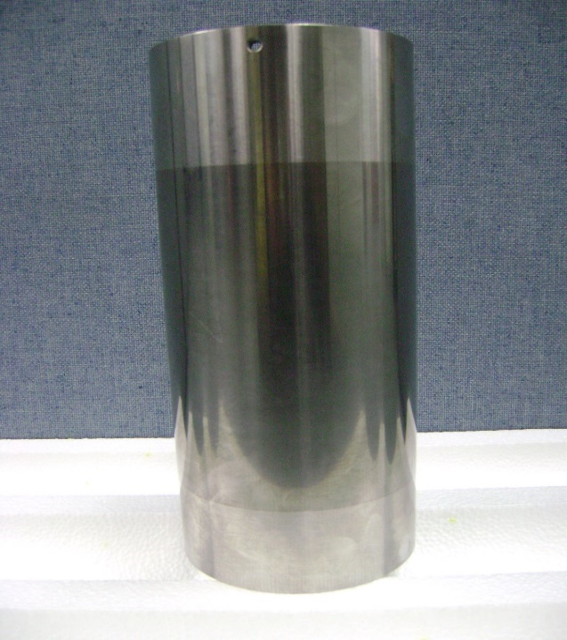*HVOF Tungsten Carbide Coated Sleeve.*

Propeller shaft with arc spray process

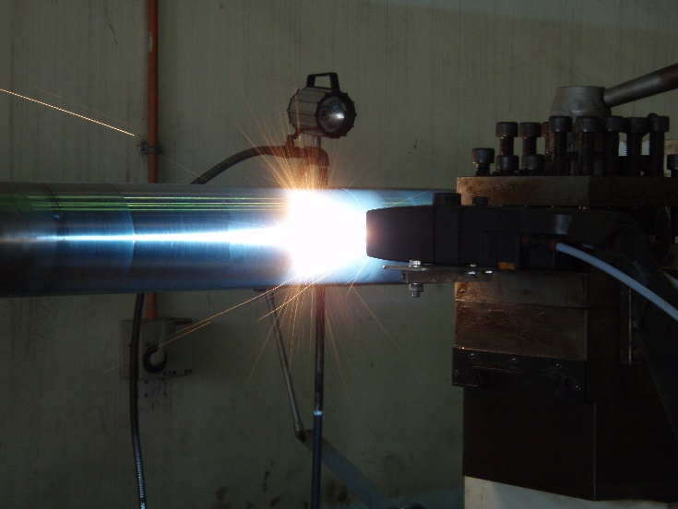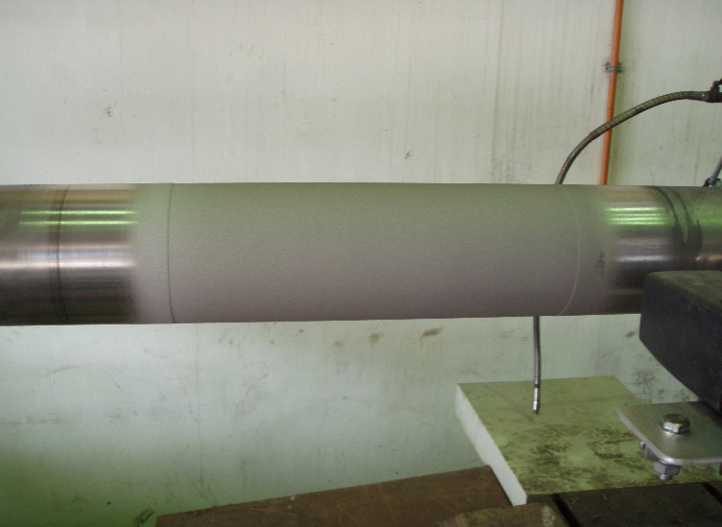

KB ENGINEERING COATINGS SDN. BHD(Co. No: 831283D)

No. 22, Jalan TS 6/9, Taman Industri Subang, 47510 Subang Jaya, Selangor Darul Ehsan

Restoration of worn out area of a pump shaft

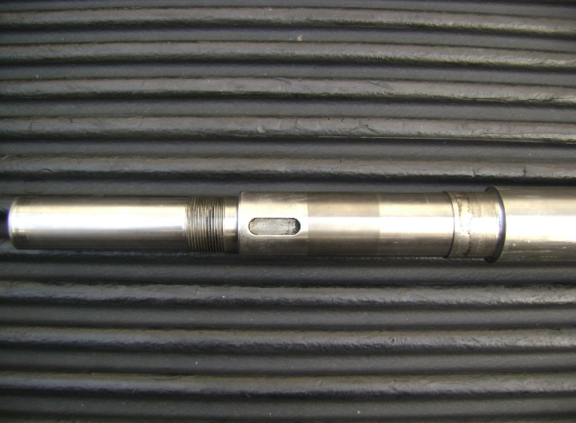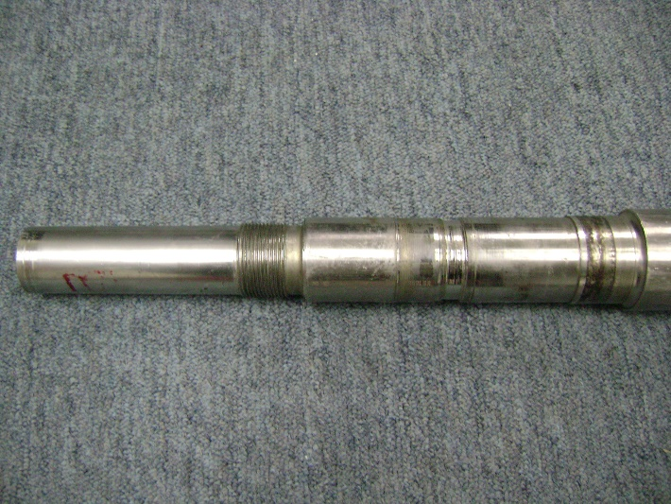

HVOF (JP 5000)

Tungsten Carbide Coating for Pump Impellers

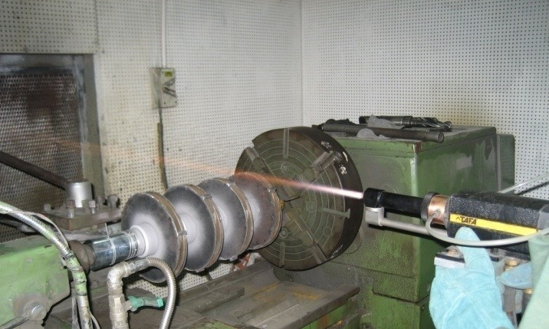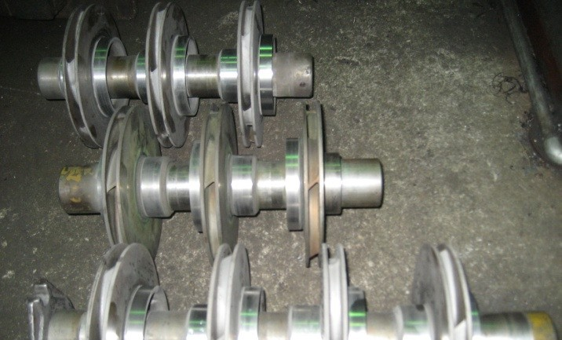

KB ENGINEERING COATINGS SDN. BHD(Co. No: 831283D)

No. 22, Jalan TS 6/9, Taman Industri Subang, 47510 Subang Jaya, Selangor Darul Ehsan

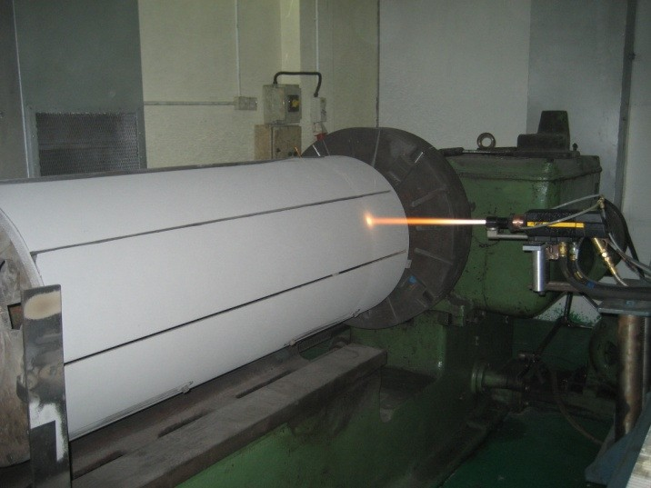HVOF (JP 5000) Tungsten Carbide

|  |
| --- |
| Thermal Spray Coatings Provide Protection For All Types of Wear and Tear.   1. Abrasion 2. Corrosion & Oxidation 3. Sliding Wear 4. Fretting 5. Galling 6. Erosion 7. Cavitation 8. Electrical Conductivity |

Onsite welding Jobs

KB ENGINEERING COATINGS SDN. BHD(Co. No: 831283D)

No. 22, Jalan TS 6/9, Taman Industri Subang, 47510 Subang Jaya, Selangor Darul Ehsan

Klin Tyre Repair

Sub Industry Focus

KB ENGINEERING COATINGS SDN. BHD(Co. No: 831283D)

No. 22, Jalan TS 6/9, Taman Industri Subang, 47510 Subang Jaya, Selangor Darul Ehsan

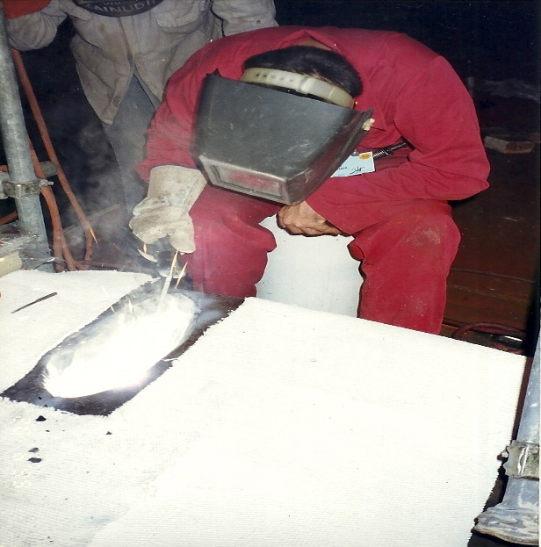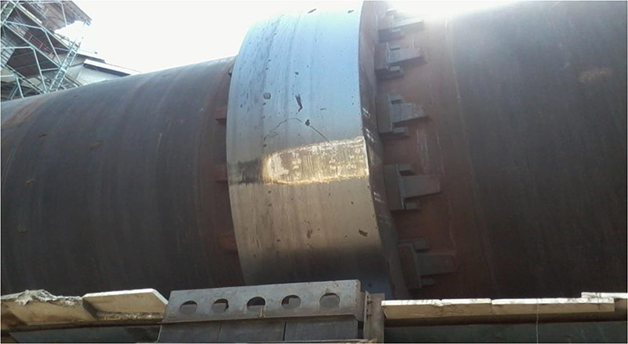

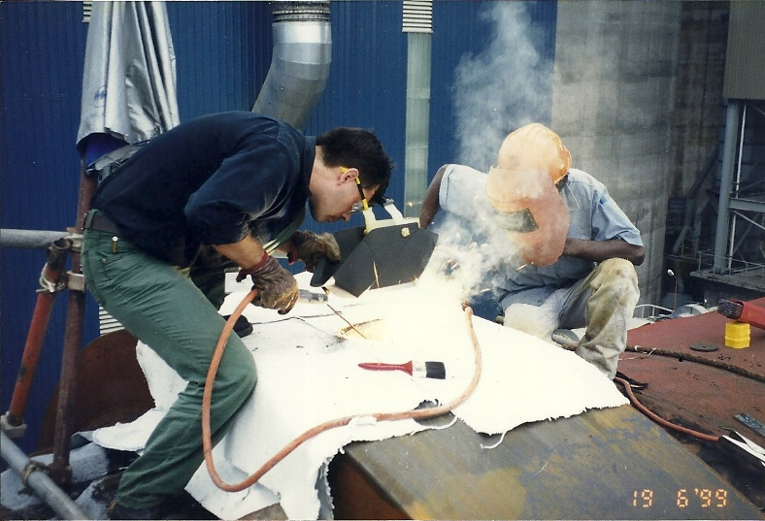

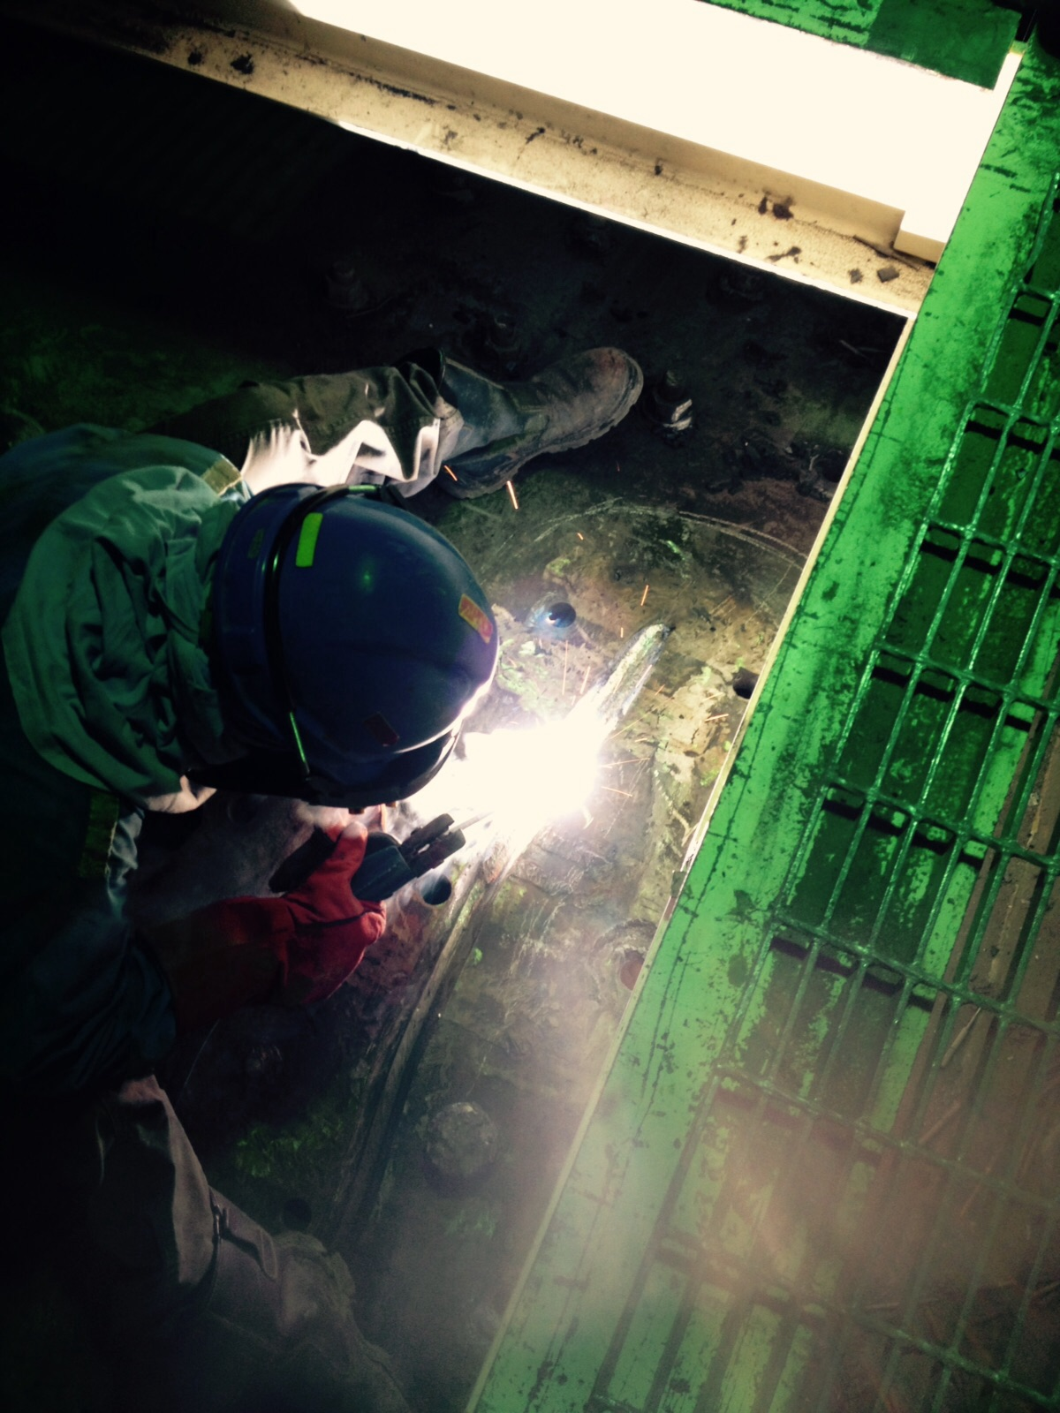Ball Mill Crack Repair

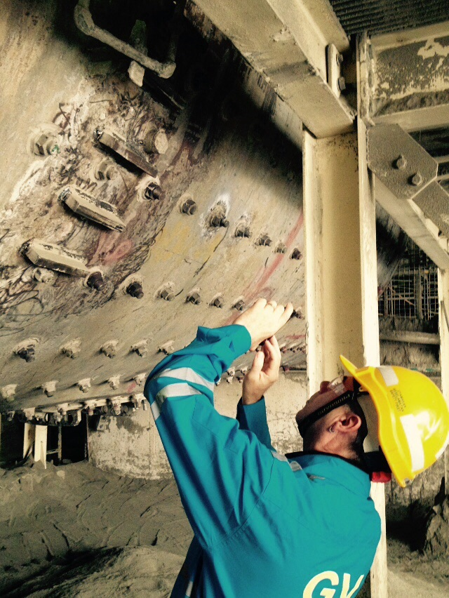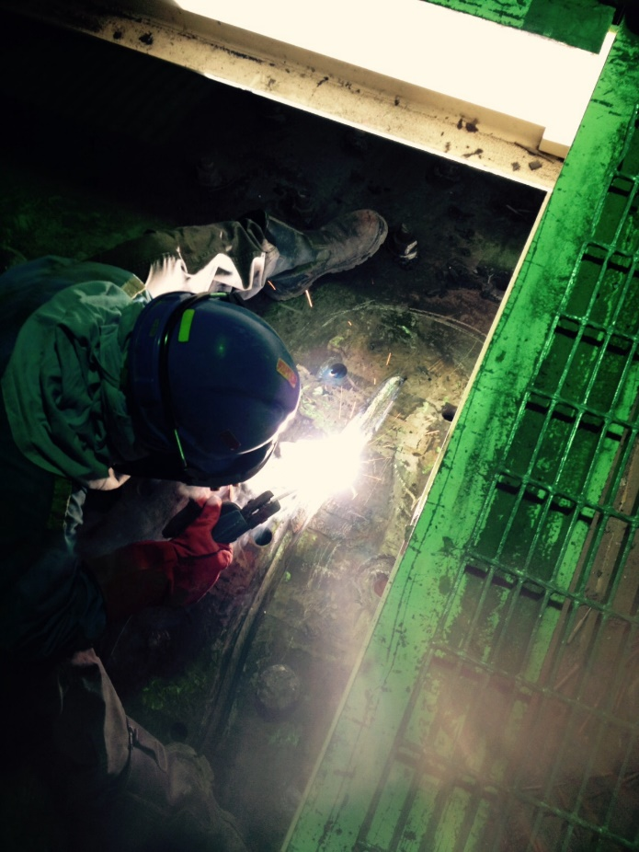

Ball Mill Pinion Gear Repair

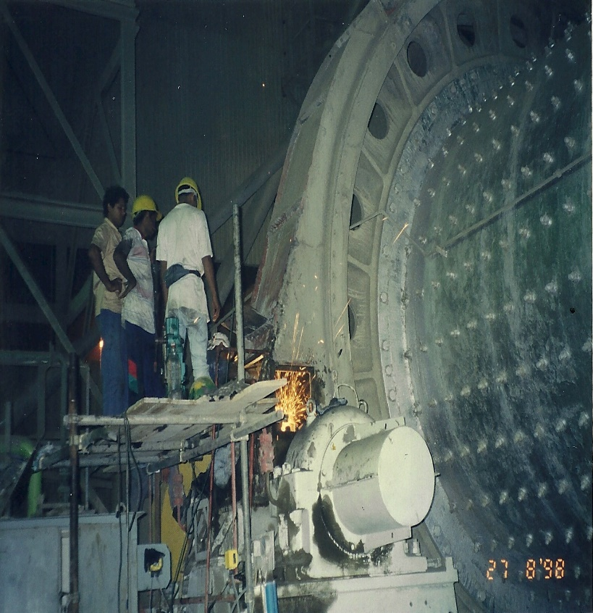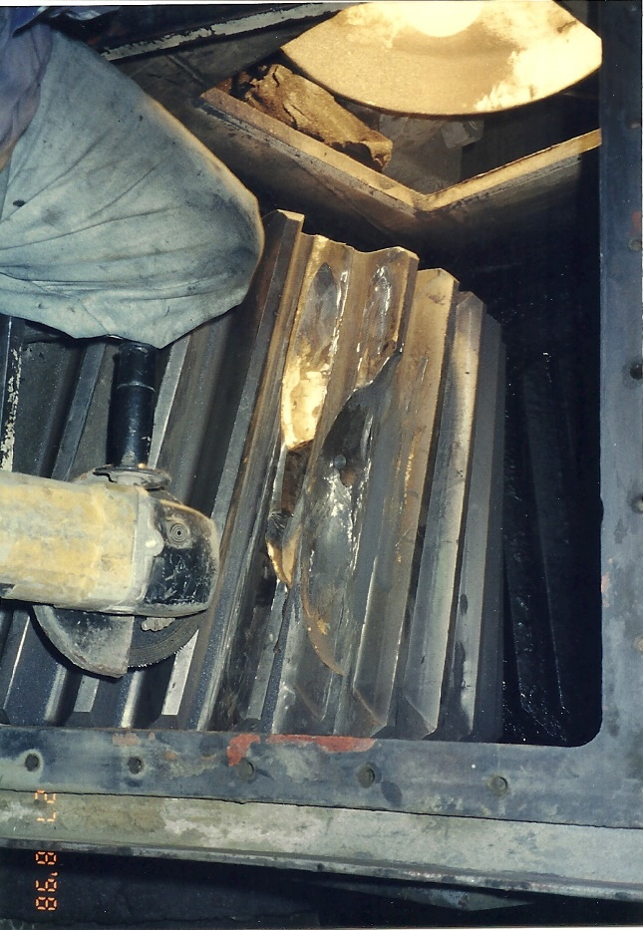

**Thank You**

for giving us this opportunity to present to your organization our company profile and we sincerely hope that we can do some business together.

*Contact our Sale Representative for a Quotation or Consultation*

1. *Stanley Davis – 0126025257*
2. *Goki - 0104270610*